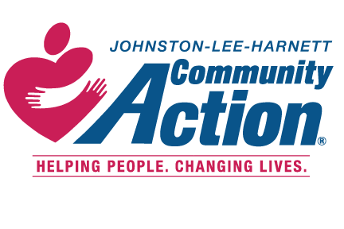 CARES NC CSBG TELL US ABOUT YOURSELF
(Covid-19 Pandemic)
**YOU WILL NEED THE FOLLOWING INFORMATION TO COMPLETE YOUR INTAKE WITH A CARES INTAKE COUNSELOR: YOUR OFFICIAL PICTURE ID, SOCIAL SECURITY CARDS FOR ALL HOUSEHOLD MEMBERS, PROOF OF INCOME FOR ALL HOUSEHOLD MEMBERS, THE BILL YOU ARE SEEKING ASSISTANCE WITH, AND DOCUMENTATION OF YOUR COVID-19 PANDEMIC RELATED CRISIS SITUATION. **
*******YOU MUST LIVE IN JOHNSTON LEE OR HARNETT COUNTY AND MEET THE ELIGIBILITY GUIDELINES TO RECEIVE SERVICES IN THE CARES PROGRAM (COVID-19) *****
Name Telephone/Cell# ____________
Address Date _______________________________
Email Address Time ______________________________
Welcome to Johnston-Lee-Harnett Community Action. Please take a few minutes and complete this survey so that we may better understand your situation AS IT RELATES TO THE COVID-19 PANDEMIC.
- Was your situation caused by the COVID-19 Pandemic? Yes_____ No____, if yes, please explain
_____________________________________________________________________________________
______________________________________________________________________________________
______________________________________________________________________________________

- What type of assistance are requesting? __________________________________________________
____________________________________________________________________________________
____________________________________________________________________________________

- What can we do to help you resolve your situation?
____________________________________________________________________________________
___________________________________________________________________________________
___________________________________________________________________________________
___________________________________________________________________________________
___________________________________________________________________________________
___________________________________________________________________________________
___________________________________________________________________________________

By signing this form, I attest that the information I entered on this form is true and that my crisis situation was caused by the COVID-19 Pandemic.
Signature: ______________________________________ ___________________________________

DO NOT WRITE BELOW THIS LINE
Office Use Only:

_________________________ _______________ _______________
CARES Intake Counselors’ Signature Date Time

Assistance Granted Yes ________ No ________

