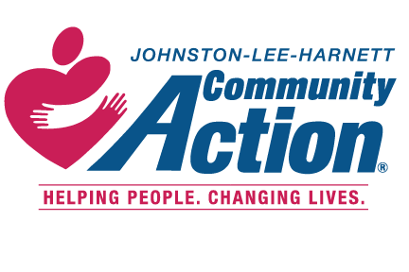 RELIEF NC CSBG TELL US ABOUT YOURSELF
(Hurricane Florence 2018)

**YOU WILL NEED THE FOLLOWING INFORMATION TO COMPLETE YOUR INTAKE WITH A CARES INTAKE COUNSELOR: YOUR OFFICIAL PICTURE ID, SOCIAL SECURITY CARDS FOR ALL HOUSEHOLD MEMBERS, PROOF OF INCOME FOR ALL HOUSEHOLD MEMBERS, THE BILL YOU ARE SEEKING ASSISTANCE WITH, AND DOCUMENTATION OF YOUR HURRICANE FLORENCE (2018) RELATED CRISIS SITUATION. ****
*******YOU MUST LIVE IN JOHNSTON LEE OR HARNETT COUNTY AND MEET THE ELIGIBILITY GUIDELINES TO RECEIVE SERVICES IN THE RELIEFNC PROGRAM (HURRICANE FLORENCE 2018) *****
Name Telephone/Cell# ____________
Address Date _______________________________
Email Address Time ______________________________
Welcome to Johnston-Lee-Harnett Community Action. Please take a few minutes and complete this survey so that we may better understand your situation AS IT RELATES TO THE HURRICANE FLORENCE (2018).
- Did your home sustain any damages from Hurricane Florence? Yes_____ No____, if yes, please explain
_____________________________________________________________________________________
______________________________________________________________________________________
______________________________________________________________________________________

- What type of damage did your home sustain? _______________________________________________
____________________________________________________________________________________
____________________________________________________________________________________

- Did FEMA or your Insurance Company cover any of the damages listed above? Yes ___ No___,
if yes please explain.
____________________________________________________________________________________
___________________________________________________________________________________
___________________________________________________________________________________

- Are you currently experiencing any Hurricane Florence related problems to your home Yes ___, No___,
if yes, please explain
___________________________________________________________________________________
___________________________________________________________________________________
___________________________________________________________________________________
By signing this form, I attest that the information I entered on this form is true and that my crisis situation was caused by RELIEF NC –Hurricane Florence.
Signature: ______________________________________ ___________________________________

DO NOT WRITE BELOW THIS LINE
Office Use Only:

_______________________________ _______________ _______________
Relief NC Intake Counselor’s Signature Date Time

Assistance Granted Yes ________ No ________

