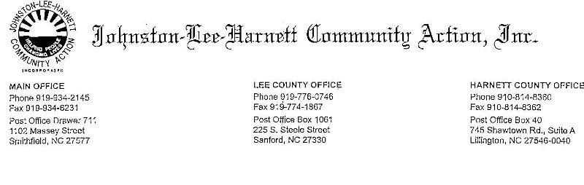

**FAMILY ADVOCATE III**

**Hours: 7:30 am – 4:30 pm**

**Location: Johnston County**

Johnston-Lee-Harnett Community Action, Inc. is seeking a Family Advocate II. The responsibilities will include:

**POSITION SUMMARY**

Under the direction of the Head Start Family Advocate Supervisor, the Head Start Family Advocate III will perform as a resource person for services for children and parents. Coordinate the outreach, recruitment and enrollment of children for the Head Start Program. Complete children assessments, family partnership agreements, family surveys and enrollment applications. Implement a comprehensive family services plan that identifies family goals, strengths, necessary services and other supports. Provide information and assistance to enrolled families in need of emergency assistance to include making referrals and providing individual case follow-up. Make regular and frequent home visits. Prepare and maintain detailed child and family records, and maintain confidentiality of all information acquired.

# POSITION QUALIFICATIONS

* Baccalaureate degree, (minimum), preferably related to Social Work, Early Childhood Education or related field.
* Prefer individual fluent in English and Spanish.
* Ability to work with disadvantaged families.
* Good interpersonal skills and ability to work effectively as a team member and with existing social service agencies, health departments, etc.
* Good organizational skills. Ability to be flexible and accept new tasks.
* Lifting children weighing up to forty (40) pounds.
* Bending at the waist, kneeling or crouching to maintain direct eye contact with children.
* Annual physical and TB screening.

**Submit a completed application, resume and 3 letters of professional reference to:**

**Johnston-Lee-Harnett Community Action, Inc.**

**Human Resource Department**

**Attn: Ruby Bryant or Alisa Bizzell**

**Post Office Drawer 711**

**Smithfield NC 27577**

**Minimum Starting pay: $27,698 year**

**Application can be completed on the website:** [**www.jlhcommunityaction.org**](http://www.jlhcommunityaction.org)

**Go to the HR Tab, the dropdown will show: EMPLOYMENT OPPORTUNITIES**

**The online application is in the purple box labeled:**

**JLHCA, INC EMPLOYMENT APPLICATION**