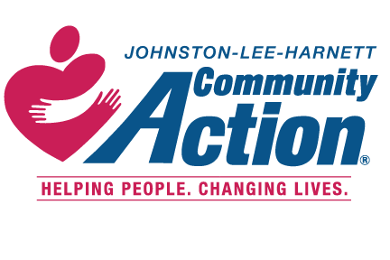CARES NC CSBG Application Instructions
If you are interested in enrolling in the CARES NC CSBG Program (COVID-19) or would like additional information about the program, please complete this preliminary application. You can email or fax the completed application to the county office in which you live. If you need assistance filling it out please contact the CARES Intake Counselor (COVID-19). You may also call to speak to the Counselor or email the completed application (recommended) to a CARES intake Counselor (COVID-19) at any of the following locations:
- Call the Johnston County office and ask to speak to a CARES Intake Counselor) at 919.934.2145, fax it to 919-934-6231 or mail the application to PO Drawer 711, Smithfield, NC 27577.
- Call the Lee County office and ask to speak to a CARES Intake Counselor at 919.776-0746, fax it to 919-774-1867 or mail the application to PO Box 1061, Sanford, NC 27330.
- Call the Harnett County office and ask to speak to a CARES Intake Counselor at 910.814.8360, fax it to 910-814-8362 or mail the application to PO Box 40, Lillington, NC 27546
- After the preliminary application has been received, you will receive an email or phone call which will include the date, counselors’ name and the time of your interview.. In order to determine if you meet the eligibility requirements and to speed up the process, you will need to submit the following items to the interview:
- Valid Picture ID
- Social Security Cards for everyone in the home related by blood, marriage or adoption.
- Proof of income for the last 90 days (if applicable) of everyone in the home related by blood, marriage or adoption.
- The bill you require assistance with which must be in your name or an adult that lives in your home.
The CARES Program is a direct result of legislation passed to provide assistance to people who were negatively impacted by the COVID-19 Pandemic. The CARES Program at Johnston-Lee-Harnett Community Action is designed to provide emergency assistance to help stabilize their households. CARES Emergency Assistance include but is not limited to rent/mortgage/utilities, food, budgeting. etc.

