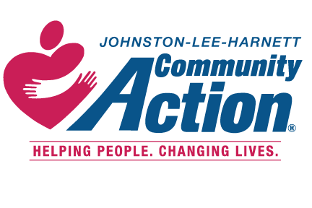 Date_______________
Community Services Block Grant
CARES NC (COVID-19) Application

The Objective of the CARES NC Program is to help meet the needs of individuals/families that are being negatively affected by the COVID-19 Pandemic only. This program is designed to help remove barriers and/or stabilize households in Johnston, Lee and Harnett Counties whose income is below 200% of the federal poverty guidelines (see below). The CARES NC Program will provide emergency assistance to help prevent disconnections, evictions, food shortage and other emergency situations that could cause the breakdown of the family/individual.

Applicant Name: __________________ ____________ _______________ _____________________
Last First Middle Maiden Name (if applicable)
Street Address _________________________________________________________________________
Street Name Apt. # /Lot#
_____________________________________________________________________________________
City State Zip-code

Mailing Address (if different): _____________________________________________________________

Contact Information: ______________________ ______________________ is texting ok? Yes __ No___
Phone Number (best #) Cell Phone Number
Email address:________________________________ Other ways to contact you: ___________________

What are your goals for the future and how can we help you reach them? Check all apply)

Employment __ Education___ Affordable Housing __ Goal Setting __ Financial Literacy (budgeting) ___

2020 Poverty Guidelines for the 48 contiguous states & the District Of Columbia
Persons in family/household | Poverty guideline
For families/households with more than 8 persons, add $8960 for each additional person.
1 | $25, 520
2 | $34,480
3 | $43,440
4 | $52,400
5 | $61,360
6 | $70,320
7 | $79,280
8 | $88,240
For each additional person add | $8,960

